User inputs rectangle around desired foreground

Gaussian mixture model is used to model the foreground and background

GMM learns and creates new pixel distribution based off of color statistics

Pixels are nodes and edges between are weighted based on color difference

A minimal cut algorithm is used to segment the graph

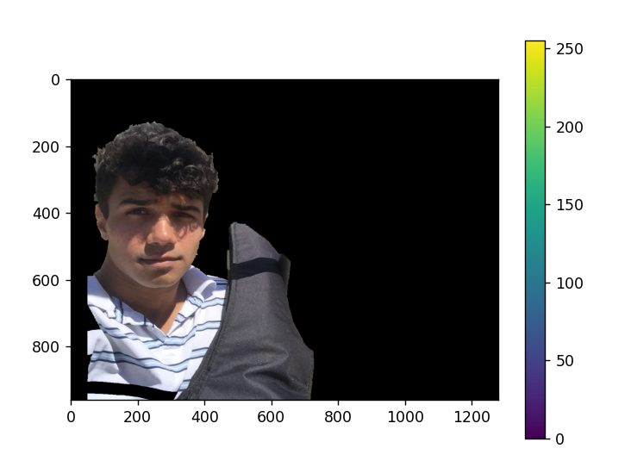

Effects on luke.jpg